**Air Ticket Reservation System**

Design Document

Mursil Sayed

**AbstracT**

This document contains high-level requirements analysis, High-level presentation of the data model & Architecture diagrams describing the composition and working of the system, component diagrams and Mock UI Screens that communicates how the user will interact with the application.

Table of Contents

High Level Requirements Analysis 3

High Level presentation of the data model 3

Architecture & Component diagrams 3

Mock UI Screens 4

1. LoginScreen 4

2. Customer Find Flight Screen 5

3. Customer Select Flight for Reservation 5

4. Customer Make Payment for Reservation 6

5. Customer eTicket received via email 6

6. Customer My Bookings Screen 7

7. Staff Portal Home Screen 7

8. Staff Portal Flight Passenger Details 8

9. Staff Portal Flight Ticket Details 8

# High Level Requirements Analysis

A single page web application is needed that will consume RESTful web services so that customers can easily search flights and reserve tickets, cancel reserved tickets or choose seat & get boarding pass before 48 hours of flight. RESTful web services will promote re-usability that the same services can be consumed from a mobile app client.

Ticket reservation confirmation will be notified via email. Customers will also be notified in case airline staff decides to cancel the flight or a specific ticket.

# High Level presentation of the data model

[ER Diagram](references/ERDDiagram.png)

# Architecture & Component diagrams

This section of the document provide Deployment & Architecture diagrams describing the composition and working of the system, explaining the component interaction and process, control and data flows.

[Component Diagram](references/ComponentDiagram.png)

[Class Diagram](references/ClassDiagram.png)

[Deployment Diagram](references/DeploymentDiagram.png)

# Mock UI Screens

This section of the document provides Mock UI screens and how they are connected through user interactions with those screens

## LoginScreen

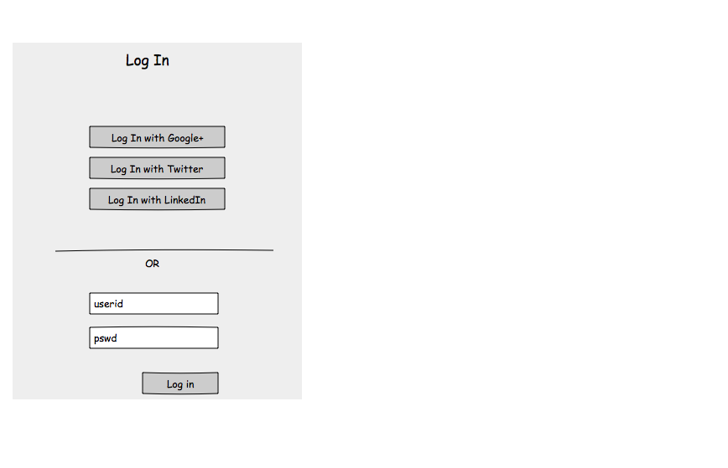

## Customer Find Flight Screen

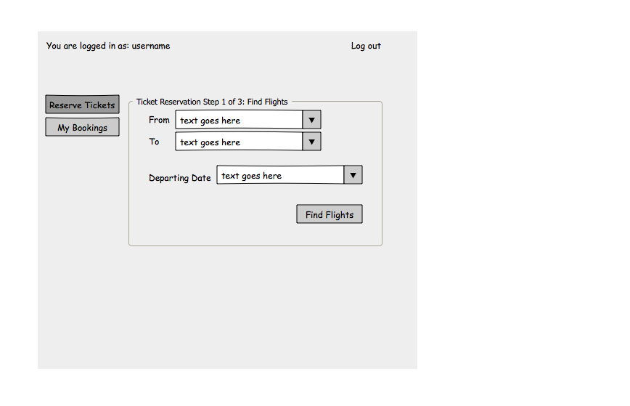

## Customer Select Flight for Reservation

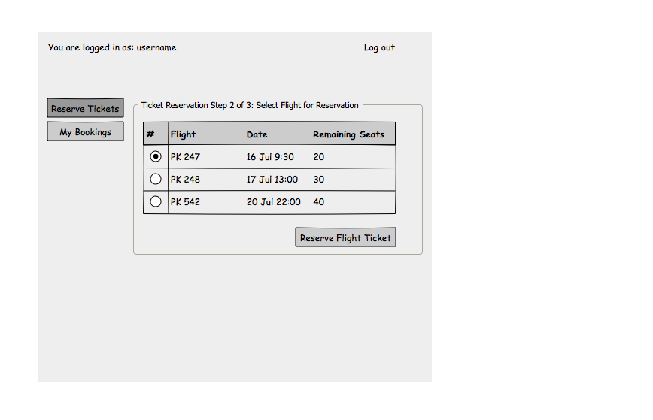

## Customer Make Payment for Reservation

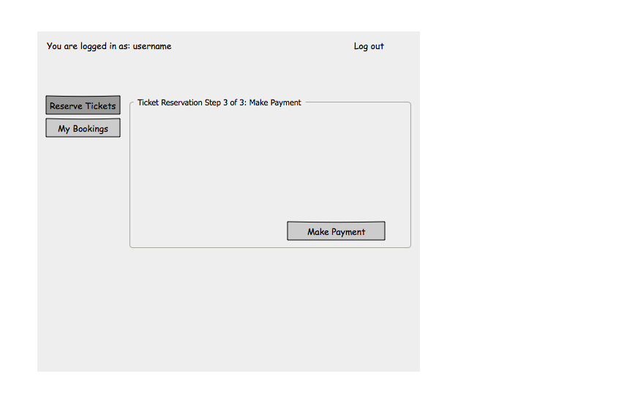

## Customer eTicket received via email

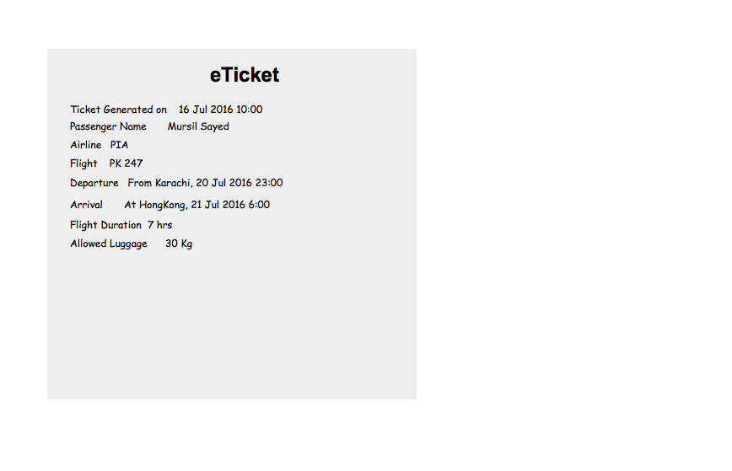

## Customer My Bookings Screen

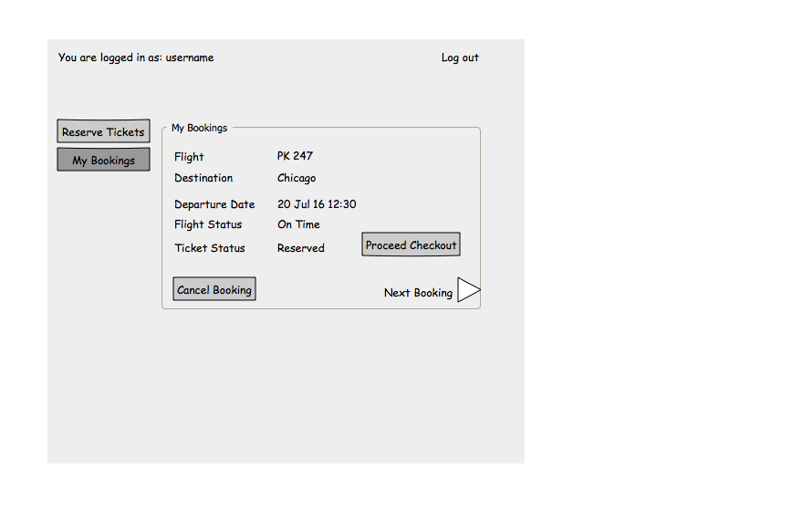

## Staff Portal Home Screen

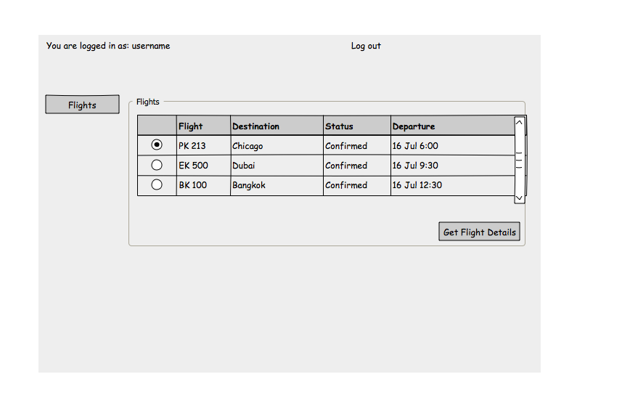

## Staff Portal Flight Passenger Details

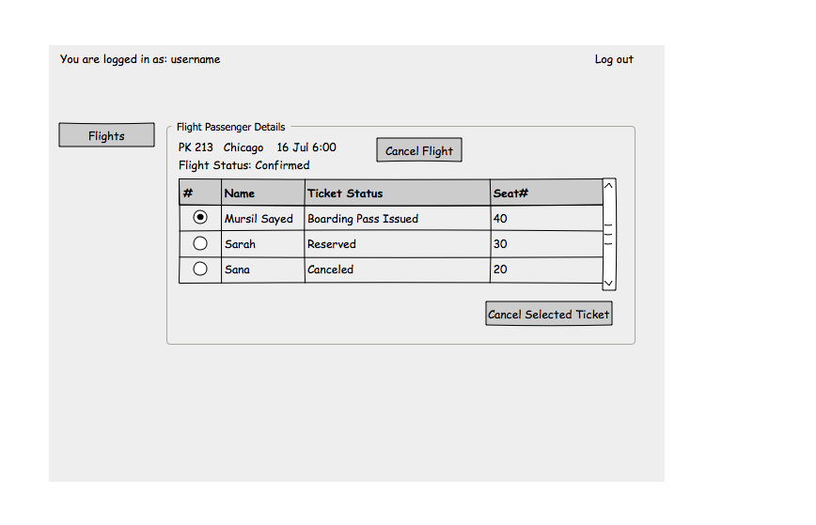

## Staff Portal Flight Ticket Details

